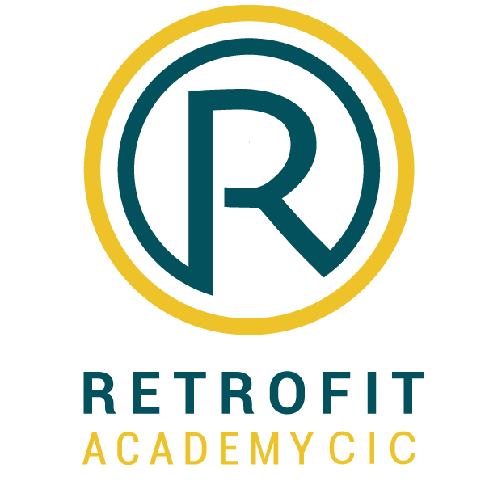

Appeals Policy & Procedures

September 2021

1. Introduction
This policy is aimed at learners enrolled on Retrofit Academy CIC (TRA) courses that are Ofqual-regulated. It sets out the basis on which enquiries and appeals can be made, the process involved, and the way in which TRA will respond to such appeals.
It is also for use by TRA staff to ensure they deal with all enquiries and appeals in a consistent manner and meet relevant regulatory requirements. The policy is intended for access by TRA staff, learners, QA personnel (IQA, assessors) and the Awarding Organisation.

2. TRA centre responsibilities
It is important that TRA centre staff involved in the management, assessment and quality assurance of its qualifications and learners are aware of the contents of the policy.
In addition, TRA centre will have internal enquires and appeals arrangements which learners can access if they wish to appeal against a decision taken by TRA. All appeals in relation to decisions taken by the TRA must go through the TRA appeals process.

3. Fees
TRA may charge a fee for formal appeals as published in our fees leaflet. TRA will only do this if it incurs a cost by bringing in an external expert. If an appeal is upheld, this fee will be refunded.

4. Internal Resolution
In all instances, the learner must first submit their enquiry in writing to the Retrofit Academy Assessor. This should be copied to the nominated Internal Quality Assurance (IQA) officer at TRA. Contact details for these individuals can be obtained by emailing training@retrofitacademy.org. and enquiries will be responded to within 7 working days.

Where a learner is not satisfied with the decision of the Assessor and/or IQA, they should contact the CEO at the TRA at the details below. The enquiry will be reviewed within 7 working days, and learner, assessor and IQA provided with written feedback.
If the learner is still unsatisfied with the final decision, they should be advised to contact the relevant Awarding Organisation, with TRA supplying their contact details at this juncture.

5. Scope of this policy
The enquiries and appeals process is in two stages:
Stage one, The Retrofit Academy will consider enquiries about decisions made regarding:
- Assessment
- Teaching
- Reasonable Adjustments and Special Considerations; and
- Malpractice and Maladministration.

Stage two is the formal appeals stage and only decisions regarding:
- Assessment
- Reasonable Adjustments and Special Considerations; and
- Malpractice and Maladministration.

Note:
Where the regulators notify TRA of failures that have been discovered in the assessment process of a TRA Awarding Organisation, TRA will review whether a similar failure could affect its own assessment processes and arrangements. In this instance, where TRA must adjust assessment decisions, there will be no appeals process.

6. The Enquiries and Appeals Process
Appellants have 20 working days from the date they were informed of the decision, including assessment results, to make an enquiry; so, learners and TRA Centre staff are advised to retain all evidence of achievement until results are confirmed.

6.1 Before making the Enquiry
Assuming the learner is not satisfied with TRA’s internal resolution the learner has the right to appeal to the relevant Awarding Organisation. This should be conducted by TRA in the first instance.
Where TRA Centre staff enquire on behalf of a learner (to an Awarding Organisation) they must ensure that the written permission of the learner concerned is obtained, as investigations may result in final achievements going down as well as up.
Learners who wish to enquire about their assessment results, or about a related decision, should be supported by TRA Centre staff, and should have exhausted TRA’s own appeals process before approaching the Awarding Organisation.
Learners must provide TRA with evidence that they have first gone through their appeals process. It is expected that learners will only contact the Awarding Organisation directly in exceptional circumstances.

6.2 Making the Enquiry to an Awarding Organisation
- An enquiry should be made in writing, supplying the following information:
- Learner’s name and TRA registration number
- Date(s) the learner received notification of The Retrofit Academy’s decision
- Title and number of the Retrofit Academy qualification affected, or nature of service affected (if appropriate)
- Full nature of the enquiry
- Contents and outcome of any investigation carried out by you relating to the issue.

6.3 During the enquiry
Upon receipt of all enquiries TRA will acknowledge receipt of the enquiry within 2 working days and will undertake an initial, informal assessment of the documentation to ensure the application is complete, within scope and to ascertain if the issue can be resolved.
A review of the decision will be undertaken by the TRA quality team (IQA and assessor) to ensure procedures have been applied fairly, appropriately, and consistently and in line with TRA policies.
Where the enquiry is regarding an assessment decision, a second Internal Quality Assurer (Head of Qualifications and learning) will review the original decision. Where the second reviewer overturns the decision of the first review, TRA will amend the result, reclaim any certificates issued and generate a new certificate where required.

Enquiry decisions will be reported to the relevant Awarding Organisation’s committee.

6.4 Following the Enquiry
Decisions following an enquiry will be fed back to the appellant within a further 8 working days.
Where the appellant does not accept a decision following an enquiry and that decision relates to:
- Assessment
- Reasonable Adjustments and Special Considerations; or
- Malpractice and Maladministration.
they may proceed to the formal appeals stage. All appellants will be informed of the relevant fee to take a case to the formal appeals stage.

6.5 Stage two - Formal Appeal
Appellants have 10 working days to appeal to the Awarding Organisation following a decision made at the enquiry stage and to pay any required fees. The request to go to appeal must be made in writing, either by letter or email.

Awarding Organisations will usually aim to complete the appeals process within 20 working days of receipt of this notification.
A full review of the original decision and outcome of the enquiry will take place which will consider all the evidence provided and will determine whether relevant TRA procedures have been applied fairly, appropriately, and consistently in line with TRA policy.

6.6 Following the appeal
The Awarding Organisation will write to TRA with details of the decision to either:
- Amend the original decision considering a review of any new rationale/evidence put forward.
- To confirm the original decision and provide a rationale.
If the TRA or learner is still dissatisfied with the outcome at this stage, they are entitled to raise the matter with the relevant qualification regulator (e.g., Ofqual in England).

6.7 Successful appeals and/or issues brought to our attention by Ofqual
In situations where an appeal has been successful, or where an investigation following notification from Ofqual or TRA Awarding Body indicates a failure in our processes, TRA will give due consideration to the outcome and will take appropriate actions such as:
- Identifying any other learners who have been affected and correct or, where it cannot be corrected, mitigate as far as possible the effect of the failure (e.g., and amend the results for the learner(s) affected following an appropriate investigation)
- Reviewing TRA associated processes and policies to ensure that the ‘failure’ does not occur again or mitigate the situation as far as possible if the failure that occurred cannot be corrected.

TRA will also cooperate with any follow-up investigations required by the qualifications regulators and if appropriate agree any remedial action with them.

6.8 Policy Review arrangements
TRA will review the policy biennially as part of its self-evaluation arrangements and revise it as and when necessary, in response to Awarding Organisation and learner feedback or requests from, or good practice guidance issued by, the regulatory authorities (e.g., to align with any appeals and complaints process established by the regulatory authorities such as Ofqual).

Contact details
Anyone who would like to feedback on this strategy, or have any queries about its content, please contact us on:
T: 0330 055 7629
E: training@retrofitacademy.org

Related Policies (or documentation)
- Complaints Policy
- Malpractice and Maladministration Policy
- Plagiarism policy
- Recognition of Prior Learning and Achievement Policy
- Any other policy that may constitute an appeal.

